WORKSHEET 1.3

Student Name: Ravi Shankar Singh UID: 21BCS11619

Branch: CSE Section/Group: 808-B

Semester: 4th Date of Performance:

Subject Name: Programming in Python Lab Subject Code: 21CSH-259

**Aim:**

**Program to demonstrate the use of functions and passing different types of arguments to functions.**

**Source Code:**

1. **Write a python program to calculate area of 10 different circles. Given the pie = 22/7 and radius of the circles entered by user using Simple Function, Parameterized Function, Return Type with function and return type with parameterized Functions.**
2. **Using Simple Function.**

def simple_function_area():

pie = 22/7

for i in range(10):

x = int(input("Enter the radius of the circle: "))

area = x*x*pie

print("Area of circle with radius "+str(x)+" is " +str(area)+" unit Sq")

simple_function_area()

**OUTPUT:**

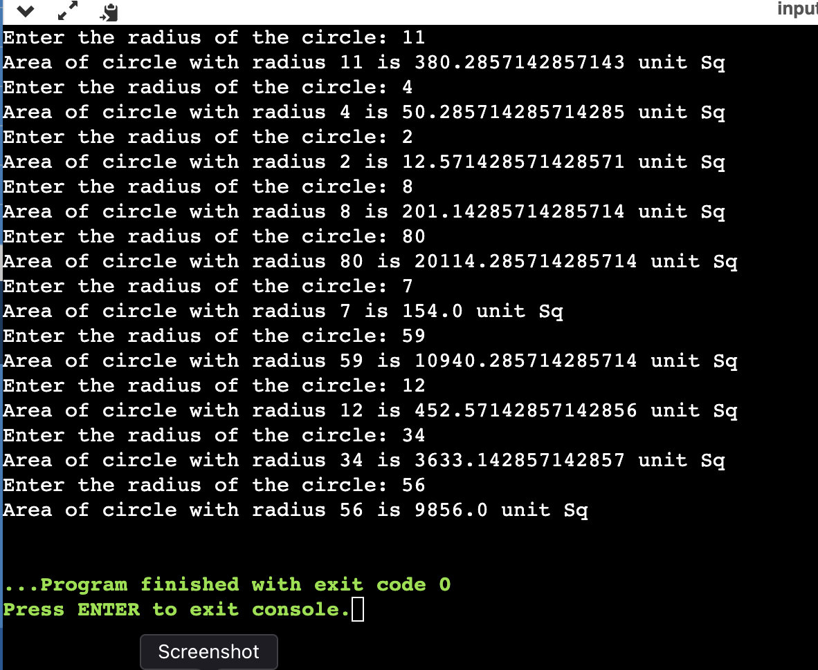

1. **Using Parameterised Function**

def parametarised_function_area(radd):

pie = 22/7

radd = x

area = x*x*pie

print("Area of circle with radius "+str(x)+" is"+str(area)+" unit Sq")

for i in range(10):

x = int(input("Enter the radius of the circle: "))

parametarised_function_area(x)

**OUTPUT:**



# **Using Function with return type**

# def simple_function_area():

# pie = 22/7

# area = x*x*pie

# return area

# for i in range(10):

# x = int(input("Enter the radius of the circle: "))

# simple_function_area()

# print("Area of the circle is "+str(simple_function_area()))

# **OUTPUT:**

# 

# **Using Parameterized Function with return type**

# def parametarised_function_area(x,pie):

# area = x*x*pie

# return area

# for i in range(10):

# pie = 22/7

# x = int(input("Enter the radius of the circle: "))

# parametarised_function_area(x,pie)

# print("Area of the circle is "+str(parametarised_function_area(x, pie)))

# **OUTPUT:**

# 

# **Write a python program to print Multiplication tables from 2 to 20 whether table values entered by user using Simple Function, Parameterized Function, Return Type with function and return type with parameterized Functions.**

# def table_simple_func():

# value = int(input("Enter table value : "))

# print("Multiplication table of ",value," : "," using simple function ")

# for i in range(1,11):

# print(f"{value} x {i} = {i*value}")

# print('\n')

# def table_parameterized_func(value):

# print("Multiplication table of ",value," using parametarised function")

# for i in range(1,11):

# print(f"{value} x {i} = {i*value}")

# print('\n')

# def table_simple_func_return():

# value = int(input("Enter table value : "))

# print("Multiplication table of ",value, " using simple function but with return type")

# table = []

# for i in range(1,11):

# table.append(str(f"{value} x {i} = {i*value}"))

# return table

# def table_parameterized_func_return(value):

# print("Multiplication table of ",value," using parametarised function but with return type")

# table = []

# for i in range(1,11):

# table.append(str(f"{value} x {i} = {i*value}"))

# return table

# table_simple_func()

# table_parameterized_func(3)

# table1 = table_simple_func_return()

# for i in table1: print(i)

# print('\n')

# table2 = table_parameterized_func_return(6)

# for i in table2: print(i)

# **OUTPUT**

# 

# 